THE AMAZING RACE TO HOUSING SUCCESS
REFLECTIONS ON HOUSING
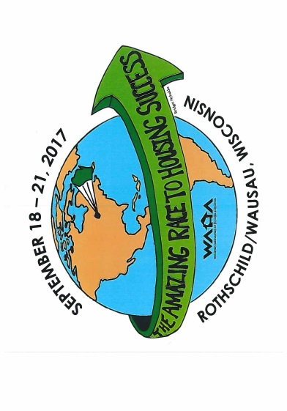

2017
Wisconsin association of housing authorities
annual conference
Hosted by District 8

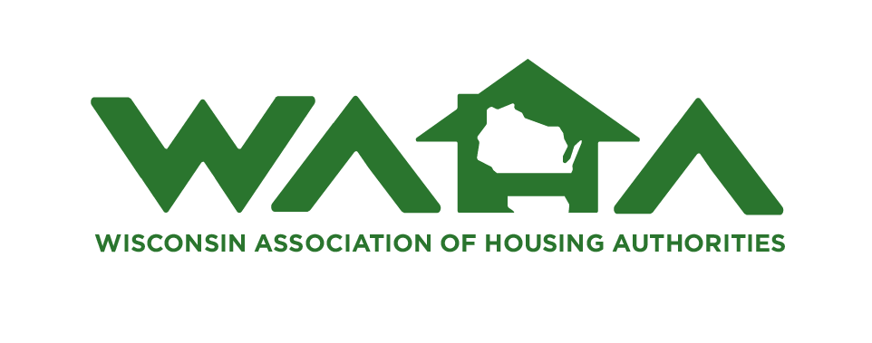
EXHIBITOR AND SPONSOR REGISTRATION

P. O. Box 365
Washburn, WI 54891
Phone: 715-209-0211 KLBennett@netzero.net

May 31, 2017

To Prospective Exhibitors/Sponsors:
The 2017 Wisconsin Association of Housing Authorities (WAHA) Annual Conference will be held September 19-21, 2017 at the Holiday Inn/Central Wisconsin Convention and Expo Center (CWCEC), Rothschild, Wisconsin. We would like to invite you to participate in this event as an exhibitor and/or sponsor.
Official exhibit hours will be from 4:30 pm to 7:30 pm on Tuesday, September 19th and 7:00 am to 9:00 am on Wednesday, September 20th in the State Ballroom of the Central Wisconsin Convention and Expo Center. In addition, we have some slots available during the Exhibitor Reception on Tuesday for any exhibitor who might want to demonstrate their product to interested attendees. There will be rooms reserved for those who would like to participate. Further information is included in the “Exhibitors” sheet attached.
Also attached is information on available Sponsorships for your consideration. These include the donation of a thumb drive with your business name on it that we can give to the Attendees with pertinent information. We expect approximately 200-250 attendees, but we welcome any number that you wish to donate. Sponsors and Exhibitors will be recognized at the luncheon on Tuesday, as well as in the Program Book.
If you are interested in participating as an Exhibitor and/or Sponsor, please complete the attached form and return it to me at the above address with a check made payable to “WAHA District 8”. Please include an e-mail address for further correspondence. Information on lodging is included in the “Exhibitors” information attached.
I look forward to working with you to ensure a successful 2017 Wisconsin Association of Housing Authorities Annual Conference.
Sincerely,
Karen
Karen L. Bennett
Conference Coordinator

EXHIBITORS
Exhibitor Fees are $325 early fee or $375 after July 1, 2017. This Fee includes:
- 8’ x 36” table space with clothed & skirted, with pipe and draping.
- 2 chairs
- Complimentary hors d’oeuvres during the Exhibitor Reception, and breakfast on Wednesday.
- Your company name and contact information listed in the Conference Program.
- Two conference registrations to attend any of the Conference Sessions.
- Two complimentary luncheon tickets for the Tuesday luncheon, during which the Exhibitors and Sponsors will be recognized.
Exhibit Hours:
- Tuesday, September 19 – 4:30 pm – 7:30 pm
- Wednesday, September 20 – 7:00 am – 9:00 am
Set-Up Hours/Restrictions:
- Exhibitors can set up displays between 1:00 and 3:00 pm on Tuesday, September 19. If you feel you need additional time, please contact Karen Bennett @ KLBennett@netzero.net.
- Nothing can be posted, tacked, or attached to the walls or other surfaces of the hotel without permission from the hotel.
- Exhibit’s should be dismantled by noon on Wednesday, September 20.

Lodging is available at the Holiday Inn & Suites Wausau-Rothschild, 1000 Imperial Avenue, Rothschild, Wisconsin at the conference group rates of $82 Single/$94 Double + tax. Call 715-355-1111 for reservations and reference either the Wisconsin Association of Housing Authorities or the “HOU” group code.
Lodging is also available at the Best Western Plus, 803 Industrial Park Avenue, Rothschild, Wisconsin (¼ mile from the Holiday Inn) at the conference rate of $82 + tax. All rooms at the Best Western Plus are kitchenettes, and a complimentary hot breakfast is provided. For reservations at the Best Western Plus, call 715-355-8900.
The cutoff date for motel reservations in our block of rooms at both motels is August 27, 2017.

EXHIBITOR REGISTRATION
Company:_____________________________________________________________________________ Address:_______________________________________ City___________________________________
State:___________________ Zip Code:__________ Phone:___________________________________
Representative(s) Attending (Name & Position):____________________________________________
E-Mail:________________________________________________________________________________
Reservation Fees for Exhibitors
Early Bird - On or Before July 1, 2017 $325 $___________
After July 1, 2017 $375 $___________
Electricity Needed: Yes_____ No_____
If Yes, Forms will be mailed to you for you to bring to the Conference when you come to set up
your exhibit. The Form, along with a check in the amount of $15 payable to CWCEC, will be
collected by the CWCEC staff at that time.
Type of Display:
Floor-Standing Booth ___ or Table Top ___; If Floor -Standing, do you also want a table Yes___ No___
The Exhibitor Reception and Wednesday Breakfast will be complimentary; We will also provide
2 tickets for the Tuesday Luncheon at which you will be recognized. Please indicate if you
will be attending the Tuesday Luncheon Yes_____ No_____
If you need additional tickets for Tuesday Luncheon $ 18 x _____ $__________
ADDITIONAL OPPORTUNITIES:
Opportunity to provide ½ hour demonstration on your product during Exhibitor Reception
Included at no cost to Elite and Platinum Sponsorships
For vendors other than Elite and Platinum Sponsorships $ 100 $__________
(If interested, please note 1st and 2nd choices below)
Available Time Slots on Tuesday, September 19:
_____ 4:45 pm _____ 5:30 pm 6:15 pm _____ 7:00 pm
Conference Ad (¼ page*) in Conference Program: Yes_____ No_____ $ 25 $__________
Donating a door prize: Yes____ No____ (No charge for ad if donating a door prize)
*Ads must be sent to me NO LATER THAN August 31, 2017.
¼ page ad is 3 ¼ W x 4 ½ H and can be submitted in color or black & white
TOTAL AMOUNT ENCLOSED $______________
Please enclose a few business cards with your Exhibitor Registration
Please make checks payable to WAHA, District 8 and send to:
Karen L. Bennett, Conference Coordinator
P. O. Box 365
Washburn, WI 54891
SPONSORSHIP LEVELS
Elite: $5,000 and over $_______________
- Complimentary Exhibit Booth in prime area
- Name, logo and complimentary full page ad in Conference Program
- Special Sponsor Level recognition in Program Book
- Company banner may be hung in registration area
- Recognition at Luncheon on Tuesday
- Complimentary ½ hour demonstration available
Platinum - $3,000 - $4999 $_______________
- Complimentary Exhibit Booth in prime area
- Name, logo and complimentary half-page ad in Conference Program
- Special Sponsor Level recognition in Program Book
- Recognition at Luncheon on Tuesday
- Complimentary ½ hour demonstration available
Gold: $2,000 - $2,999 $_______________
- Exhibit Booth at half-price
- Name, logo and complimentary quarter page ad in Conference Program
- Special Sponsor Level recognition in Program Book
- Recognition at Luncheon on Tuesday
Silver: $1,000 - $1,999 $_______________
- Complimentary quarter page ad in Conference Program
- Sponsor Level recognition in Program Book
- Recognition at Luncheon on Tuesday
Bronze: $500 to $999 $_______________
- Sponsor Level recognition in Program Book
- Recognition at Luncheon on Tuesday
Thumb Drive with Business Name Yes____ No____
(These are needed no later than August 31, 2017) If yes, how many ____
- Recognition in Program Book
- Recognition at Luncheon on Tuesday
****************************************************************************************************SPONSOR REGISTRATION
(Please indicate level above)
Company:____________________________________________________________________________ Address:_______________________________________ City__________________________________
State:___________________ Zip Code:__________ Phone:__________________________________
Contact:____________________________________ E-Mail:___________________________________

