..
THE AMAZING RACE TO HOUSING SUCCESS
REFLECTIONS ON HOUSING
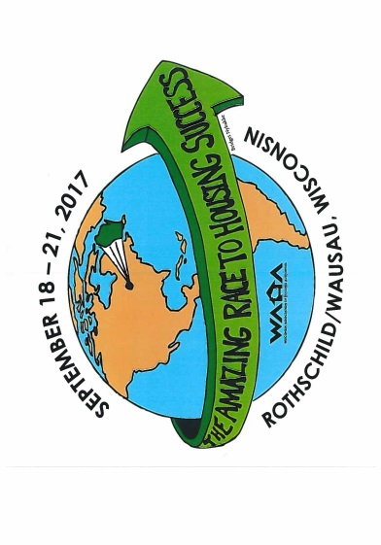

2017
Wisconsin association of housing authorities
annual conference
Hosted by District 8

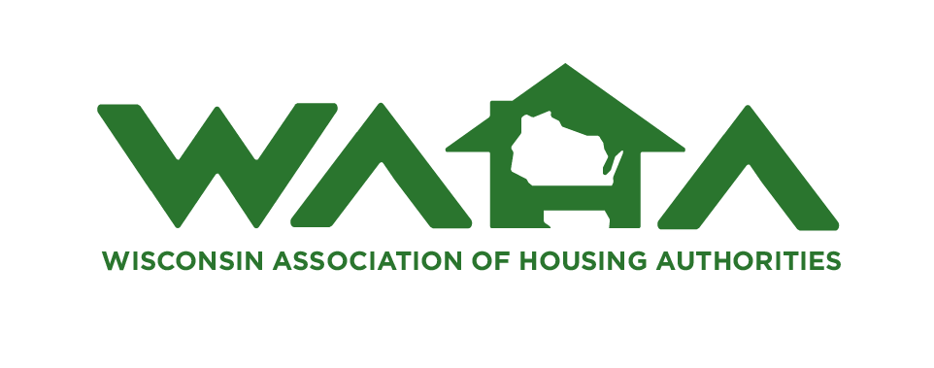
SEPTEMBER 18-21, 2017
HOLIDAY INN – CENTRAL WISCONSIN CONVENTION & EXPO CENTER, WAUSAU/ROTHSCHILD, wiSCONSIN
2017 WAHA ANNUAL CONFERENCE REGISTRATION
(Please Fill Out a Form for Each Person Attending)
Name:_______________________________________________ Title______________________________
Agency:________________________________________________________________________________
Address:_______________________________________________________________________________
City:_________________________________________ State:_______ Zip Code:__________________
E-Mail Address:____________________________________________ Phone:_____________________
Registration Fees for WAHA Members and Associate Members
Full Conference Registration (Includes all sessions, meals, breaks, receptions - Mon-Thurs):
Early Bird - On or Before August 1, 2017 $375 $____________
After August 1, 2017 $425 $____________
Partial Conference Registration
>Maintenance Workshop – Tuesday ONLY (Includes training, meals, breaks &Vendor Reception on Tuesday):
Does not include Breakfast with the Vendors on Wednesday.
Early Bird – On or before August 1, 2017 $150 $____________
After August 1, 2017 $175 $____________
>Maintenance Workshop – Wednesday ONLY– (Includes training, meals, breaks & Banquet on Wednesday):
Does not include Breakfast on Thursday.
Early Bird – On or before August 1, 2017 $275 $____________
After August 1, 2017 $300 $____________
>Maintenance Workshop Tuesday and Wednesday $325/$350 $____________
>Commissioner’s Day (Wednesday)
Early Bird - On or Before August 1, 2017 $275 $____________
After August 1, 2017 $300 $____________
TOTAL REGISTRATION FEES $____________
(All Executive Directors, Staff, Commissioners, etc. attending the Conference must pay a Registration Fee.)
Indicate Banquet meal choice: _____Sirloin Steak w/Shrimp; _____ Chicken Monterrey w/Shrimp; _____ Spinach Tortellini ***************************************************************************************************Additional Meal Tickets:
Tuesday Breakfast _____ @ $ 12.00 $____________
Tuesday Lunch _____ @ $ 18.00 $____________
Wednesday Breakfast _____ @ $ 20.00 $____________
Wednesday Lunch _____ @ $ 21.00 $____________
Wednesday Banquet – Choose one of the following: _____ @ $ 48.00 $____________
Sirloin Steak w/Shrimp_____; Chicken Monterrey w/Shrimp_____; Spinach Tortellini_____
Thursday Breakfast _____ @ $ 21.00 $____________
TOTAL ADDITIONAL MEALS $____________
TOTAL REGISTRATION FEE AND ADDITIONAL MEALS $___________
If you plan to attend the Monday/Tuesday Environmental Session, please indicate here so we can plan for adequate space/materials ______. If you are registered for the Conference, there is no additional charge for this. If you are not attending the Conference, there is a $75 fee which includes lunch and break on Monday, Meet and Greet Monday evening, Breakfast on Tuesday and Tuesday morning break.
Please indicate any dietary restrictions for health reasons (other than the alternative vegetarian Banquet meal) or special accommodations needed for the sessions: ________________________________________________________________
Full Registration Includes
All Sessions throughout the Conference.
All Breaks and Receptions
All Meals including the banquet dinner, awards and entertainment
One-Day Registration Includes:
All Sessions either Tuesday or Wednesday
All Breaks/Reception either Tuesday or Wednesday
All Meals Tuesday or Wednesday
*Breakfast with the Vendors on Wednesday is NOT INCLUDED in “Tuesday Only” Registrations*
**Breakfast on Thursday is NOT INCLUDED for “Wednesday Only” Registrations**
Additional meal tickets may be purchased on the previous page under “Additional Meal Tickets"
If you are a full conference registrant, please indicate if you plan to attend any of the following sessions:
Maintenance Training: ____________ Commissioner’s Workshop: ____________
Also, in order to keep from wasting food, please indicate if you plan to stay for Thursday Breakfast ___Yes ___No
Make checks payable to “WAHA – District 8”.
Send check & completed Registration Form(s) to:
Karen L. Bennett, Conference Coordinator If you have questions, e-mail:
P. O. Box 365 KLBennett@netzero.net
Washburn, WI 54891 (No Refunds after 9-3-17) or call: 715-373-2783
For those who may arrive on Monday evening, we are planning a MEET & GREET from 6:30 pm - ???. We hope you will join us for refreshments and a chance to relax and visit with friends before “getting down to business”.

HOTEL INFORMATION 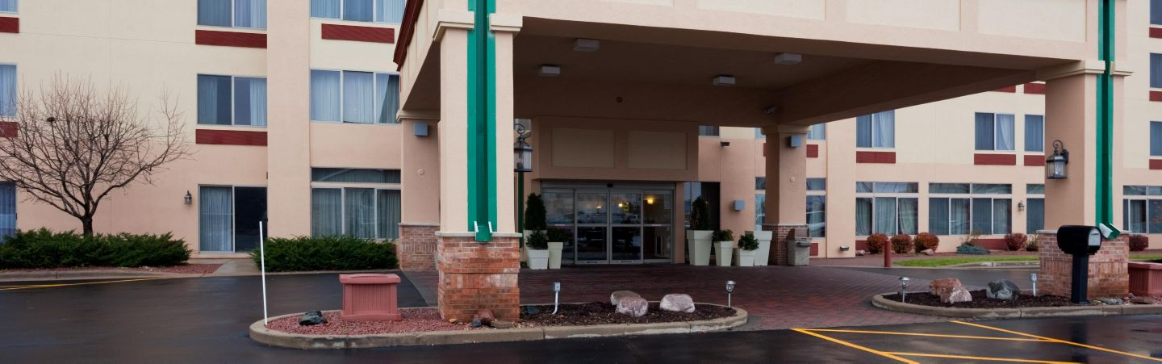
The Conference Hotel is the Holiday Inn & Suites Wausau-Rothschild, 1000 Imperial Avenue, Rothschild, Wisconsin. The Holiday Inn® Wausau - Rothschild is located off I-39/51 at exit 185. They have a continental breakfast each day and free internet. Room rates are $82 Single; $94 Double; $106 Triple.
Call 715-355-1111 for reservations and mention that you are with the WAHA group or give the “HOU” code.
The overflow hotel, the Best Western Plus at 803 Industrial Park Avenue, is located ¼ mile from the Holiday Inn & Suites, and is also located off I-39/51 at exit 185. All rooms are kitchenettes and there is a complimentary hot breakfast served daily. The room rate is $82. Call 715-355-8900 for reservations and mention that you are with the WAHA group. Anyone with a mobility problem may want to register early at the main hotel.
The cut-off date for both hotels is August 27, 2017. Don’t forget to bring your tax exempt certificates when you check in.

TENTATIVE CONFERENCE SCHEDULE
(Schedule is subject to change)
MONDAY, September 18, 2017
9:00 – 11:00 Registration
10:00 – 5:00 “Environmental Review Requirements, Responsibilities for PHA under
New 5-Year Plan Requirements” – David Nuccio, MN/WI Environmental
Coordinator
4:00 WAHA Board Meeting
5:00 – 7:00 Registration
6:30 - ??? Meet & Greet (All Attendees are Welcome)
TUESDAY, September 19, 2017 (International Day)
7:30 – 4:00 Registration
7:30 – 8:30 Continental Breakfast
8:30 – 9:00 Announcements & Welcome
9:00 – 10:15 Keynote Speaker – Jonathan Bowman “The Fine Art of People Power”
10:30 – 12:00 BREAK-OUT SESSIONS:
- “Workers Misclassified as Independent Contractors” – Corey Walton
- “Power of Attorney” – Paul Sturgul
- “Emergency Procedures & Disaster Planning” – Marytha Blanchard
- “Hoarding” – Brenden McDaniel
10:30 – 12:00 “Environmental Review Requirements, Responsibilities for PHA under New 5 Year Plan Requirements” (Continuation)
10:30 – 12:00 PIC ROOM
12:00 – 1:00 LUNCH
1:15 – 2:30 MAINTENANCE TRAINING – Contracting & Bid Pkgs; Construction Docs
1:15 – 2:30 BREAKOUT SESSIONS:
- “How to Deal with Mental Illness – LaureAnn Blanchard
- “RD Updates” – Stephanie Kelnhofer & Donna Heubner
- “Power of Attorney” (Repeat)
- “HCV Updates” – Dena Hunt, HUD
- “Operating Subsidy Process” – Anne Steffel, HUD
1:15 – 2:30 PIC ROOM
2:45 – 4:00 MAINTENANCE TRAINING – Labor Relations
2:45 – 4:00 BREAK OUT SESSIONS
- “HR 37 Changes – HTMA Update” – Mary Hirsch-Justice
- “Active Shooter Awareness and Preparedness” – John Busch
- “RD Multi-Family Housing” – Donna Huebner & Dirk Williams
- “Hoarding” (Repeat)
- “Operating Subsidy Process” (Continuation)
4:30 – 7:30 VENDOR RECEPTION
WEDNESDAY, September 20, 2017 (USA Day)
7:00 – 4:00 Registration
7:00 – 9:00 BREAKFAST WITH THE VENDORS
7:00 – 12:00 “Amazing Race Thru the Bedroom” – Find where the “Drugs” are Hidden
9:00 – 10:15 MAINTENANCE TRAINING – Preparing for REAC Inspections, Preventative
Maintenance, Mold, Maintenance Professionalism – Len Campbell
9:00 – 10:15 COMMISSIONER WORKSHOP – “10 Need to Know Facts about Running a
Housing Authority” - Rebecca Kralewski, Anne McAlpine, Anne Steffel
9:00 – 10:15 CONCURRENT SESSIONS
- “Insurance – Property and Other HA Needs” - Ken Merrifield
- “Internal Controls for Agencies with Limited Staff/Fraud Examples” – Sheri Springer
- “Labor Law Changes – Dean Dietrich
- “Active Shooter Awareness and Preparedness” (Repeat)
- “Capital Planning Process” – Scott Koegler, HUD
- “Integrated Pest Management – Dee Schultz, HUD
9:00 – 10:15 PIC Room
10:45 – 12:00 GENERAL SESSION – (Also for Maintenance & Commissioners)
“Drugs Hiding in Plain Sight” – Melinda Pauls & others
10:45 – 12:00 MAINTENANCE TRAINING (Attend General Session on Drugs)
10:45 – 12:00 COMMISSIONER WORKSHOP (Attend General Session on Drugs)
10:45 – 12:00 PIC ROOM
12:00 – 1:30 Lunch & Annual Meeting
1:30 – 2:45 GENERAL SESSION – (Also for Maintenance & Commissioners)
“Drugs Hiding in Plain Sight” (Continuation)
1:30 – 2:45 MAINTENANCE TRAINING (Attend General Session on Drugs)
1:30 – 2:45 COMMISSIONER’S WORKSHOP (Attend General Session on Drugs)
1:30 – 2:45 PIC Room
2:45 – 4:00 “Amazing Race Thru the Bedroom”
3:15 – 4:30 MAINTENANCE TRAINING – (Continuation)
3:15 – 4:30 COMMISSIONERS WORKSHOP – “Budget & Financials” – Anne Steffel,
HUD
3:15 – 4:30 CONCURRENT SESSIONS:
- “Final Rule on Smoke-Free Housing” – Jaime Zach
- “How to be Well Prepared when you go to Court” - Judicare
- “WHEDA Session”
- “HR Basics” – Dean Dietrich & Kevin Terry
- “Capital Planning Process” – (Continuation)
3:15 – 4:30 PIC ROOM
5:30 – 6:30 SOCIAL HOUR
6:30 PM BANQUET & ENTERTAINMENT
THURSDAY, September 21, 2017
7:00 – 8:00 BREAKFAST
8:00 – 9:00 “PHA Training /Updates” – Dee Schultz, HUD

9:00 – 9:30 GENERAL SESSION – Response to General Q & A; Comments
9:30 Panel of Drug “Experts” – Rick Nybakke, Indianhead Community Action
Agency; Melinda Pauls, Wausau Police Dept.; Jeffrey Wallace, Rusk Co.
Sheriff Dept. & Others
Response to Drug Q & A

NOTE: We will have a silent auction during the Conference with the proceeds going to the Scholarship Fund.

